Reading
- Read a story about an ANIMAL
**Lots of stories are available to listen to on YouTube, if you don’t have an animal book at home**
- Sing the ABCs together

Math
- Count all of the windows and doors in your house
- Go on a Shape Hunt around the house

Language
- Find pictures or toy animals around the house. Talk about the name of the animal, the sound it makes, where it lives, its color, size, etc.
Self Help
- Practice washing your hands with soap and warm water. Wash for as long as it takes to sing the ABC song.
Social-Emotional
- Identify familiar people in photos
- Take turns being “Simon” in Simon Says
Ideas found at https://www.pinterest.com/pin/485685141054644909/
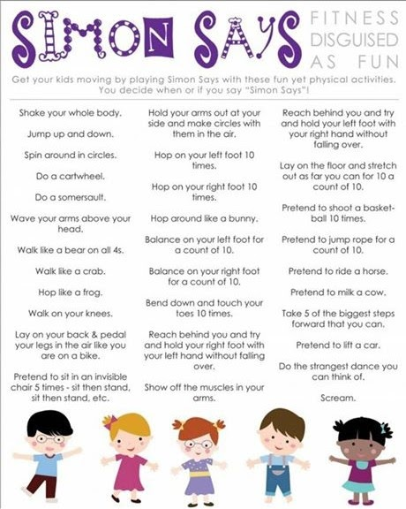

Outside/Gross Motor
- Draw with chalk
- Climb stairs, alternating feet

Fine Motor
- Paint with a Q-tip
- Ripping paper

